SIMATS ENGINEERING
SAVEETHA INSTITUTE OF MEDICAL AND TECHNICAL SCIENCES
COMPUTER SCIENCE AND ENGINEERING PROGRAMME
CSA1302 - THEORY OF COMPUTATION

LAB EXPERIMENT - 1

Name: J . Anisha Jenifer
Reg No: 192511004

QUESTION
1. Write a C program to simulate a Deterministic Finite Automata (DFA) for the
given language representing strings that start with a and end with a

1. AIM
To write and execute a C program to simulate a Deterministic Finite Automaton (DFA) that accepts strings over the alphabet {a, b} which start with 'a' and end with 'a'.

2. ALGORITHM
- Start the program.
- Read a string containing only the symbols 'a' and 'b'.
- Initialize the DFA state to the start state.
- Scan the input string from left to right and update the state according to the current symbol.
- If the first symbol is 'b', move to a rejecting state because the string does not start with 'a'.
- If the string starts with 'a', track the most recent symbol: move to an accepting state when the current symbol is 'a', and to a non-accepting state when it is 'b'.
- After processing the entire string, accept it if the final state represents a string that starts with 'a' and ends with 'a'; otherwise, reject it.
- Stop the program.

3. PROGRAM
#include <stdio.h>
#include <string.h>
int main() {
char str[100];
int i, state = 0;
printf("Enter a string (a and b): ");
scanf("%99s", str);
for (i = 0; str[i] != '\0'; i++) {
if (str[i] != 'a' && str[i] != 'b') {
printf("Invalid input\n");
return 0;
}
if (state == 0) {
if (str[i] == 'a')
state = 1;
else
state = 3;
}
else if (state == 1) {
if (str[i] == 'a')
state = 1;
else
state = 2;
}
else if (state == 2) {
if (str[i] == 'a')
state = 1;
else
state = 2;
}
else if (state == 3) {
state = 3;
}
}
if (state == 1)
printf("String Accepted\n");
else
printf("String Rejected\n");
return 0;
}

4. OUTPUT
The program was executed with the input string "abba".
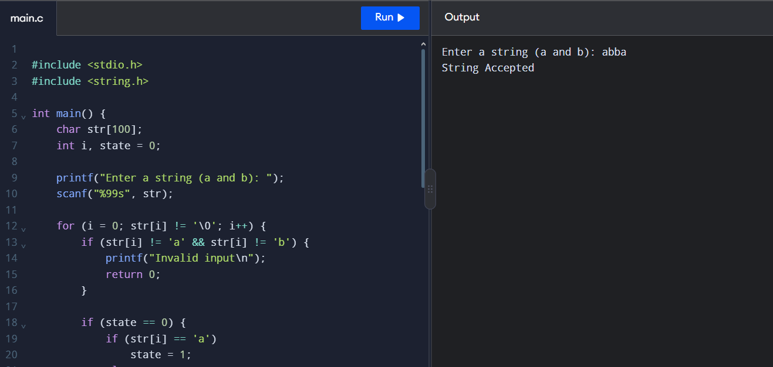
Output screenshot: Input = abba; String Accepted.

5. RESULT
Thus, the C program to simulate a DFA for strings that start with 'a' and end with 'a' was written and executed successfully. The input string "abba" was accepted.

